***PROJECT-NAME: APPLE CLONE***

***By - Abhishek sharma***

***Email - abhishek2759@gmail.com***

***Github - https://github.com/abhishekgarfield***

***Overview:*** *It is a clone of Apple(India) website. Website is completely responsive and user friendly. It has features like adding to cart , making payment, watching products and searching for products.*

***Pages:***

1. *Homepage*
2. *Login page*
3. *Signup page*
4. *Listing page*
5. *Product page*
6. *Cart page*
7. *Payment page*

***Homepage:***

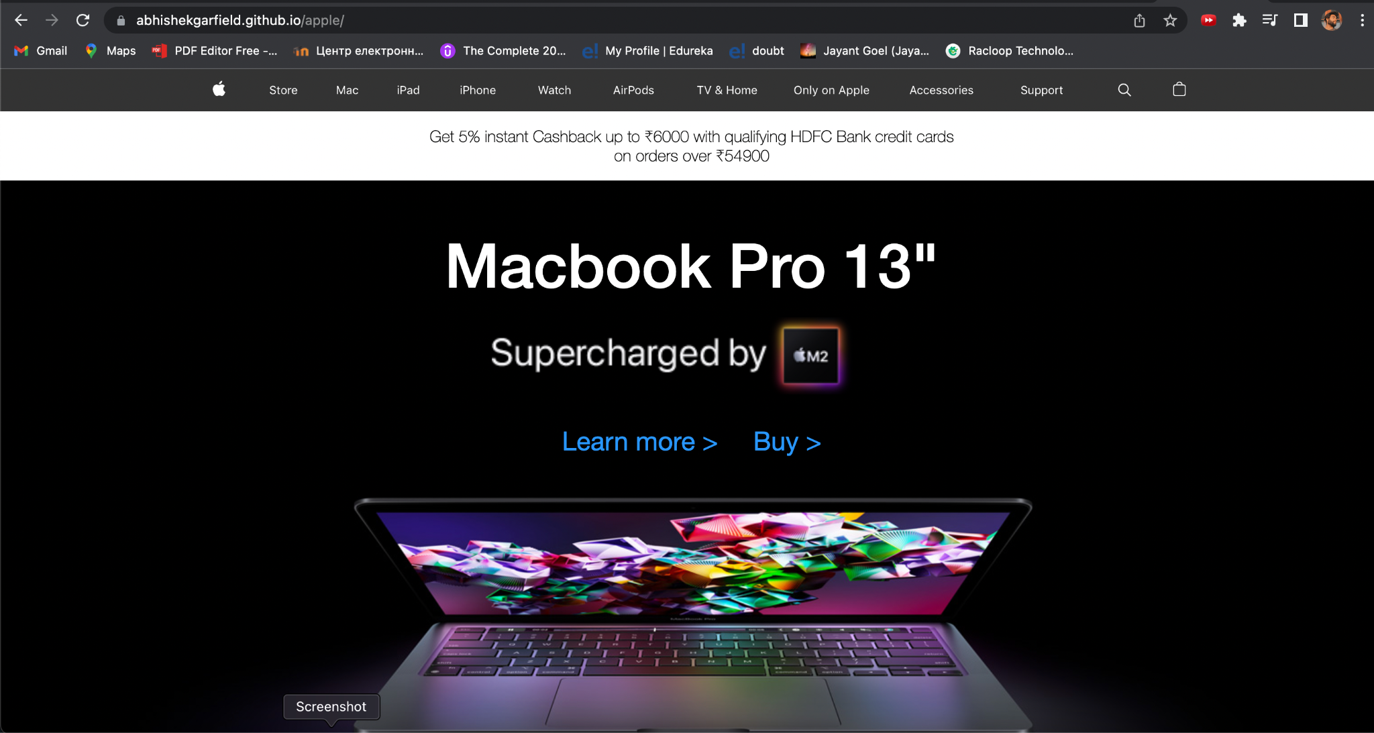

1. ***Navbar:*** *Easy navigation throughout the page with navbar. Navbar is completely responsive and compatible with a maximum number of devices.*

**

1. ***Top products:*** *All the top products are listed on the page. By clicking on it, the user can directly jump to the product page.*

*#TOP PRODUCTS* – *(DEALS - FEATURED , TRENDING )*

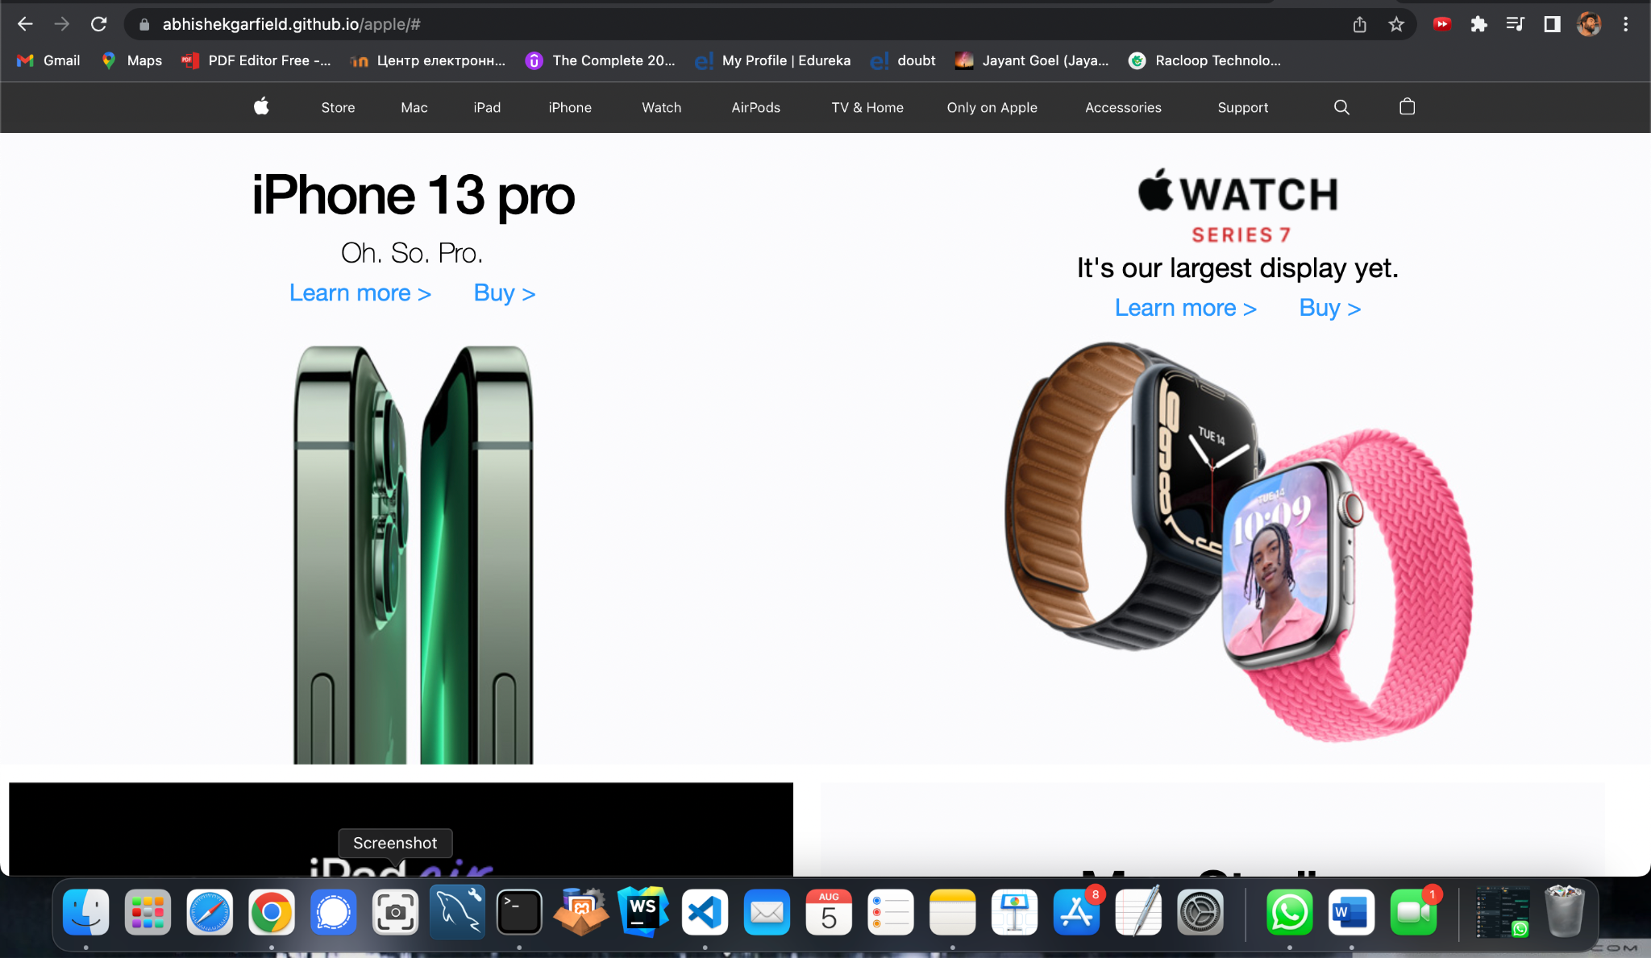

1. ***Footer:*** *All the contact details are listed in footer as well as copyright details.* # FOOTER – (CONTACT US , HELPLINES , BRIEF DESCRIPTION ABOUT THE COMPANY , SOCIAL-MEDIA HANDLE ICONS , LINK TO MOBILE APP)

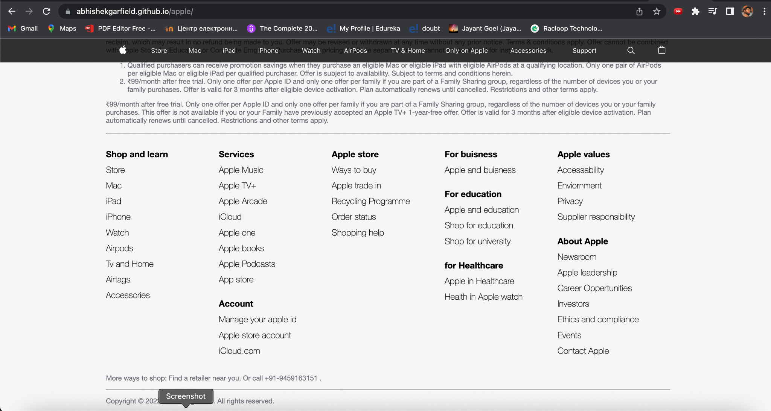

***Login page:***

1. *Username: User needs to enter his username that was registered with us.*
2. *Password: User needs to enter password entered while sign up.*

***Sign up:*** *User needs to enter his details for registering on the website.*

1. *Username: User needs to enter his name with which he/she wants to register.*
2. *Password: User needs to enter his password with which he/she wants to register.*

***Listing page:*** *Listing of all the products will be shown on this page. It also includes a filter option , search option.*

# FILTERS - (COLOR , PRICE , RATING , SIZE , TYPE , SORT BY)

***Product page:*** *Products that will be selected from the listing page will be displayed on this page with details of the product , images , specification , pricing , color options if available. Add to cart and buy now option will also be there.*

***Cart page:*** *All the items that were chosen to be added to cart will be listed here and the user will get an option for checkout from where he can proceed with the payment page.*

***Payment page:*** *If the user wants to buy any item and he has proceeded with the checkout option from cart page or selected to buy item from product image will be listed here and user can make payment using various payment options.*

*Thank you !*